**Pracrical no.:** 4

**Title:** Android app to display message

**Roll no.:** 07, 09 **Class:** TYCM-Lin **Batch:** A

**Date:** 4 JAN 2024

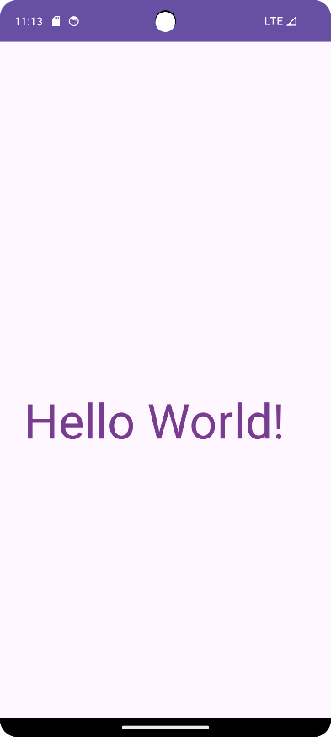<?xml version="1.0" encoding="utf-8"?>  
<LinearLayout xmlns:android="http://schemas.android.com/apk/res/android"  
 xmlns:app="http://schemas.android.com/apk/res-auto"  
 xmlns:tools="http://schemas.android.com/tools"  
 android:layout_width="match_parent"  
 android:layout_height="match_parent"  
 tools:context=".MainActivity"  
 android:orientation="vertical"  
 android:gravity="center"  
 >  
 <AbsoluteLayout  
 android:layout_width="match_parent"  
 android:layout_height="wrap_content"  
 >  
 <TextView  
 android:layout_width="wrap_content"  
 android:layout_height="match_parent"  
 android:layout_x="30sp"  
 android:layout_y="100sp"  
 android:text="@string/TV1"  
 android:textSize="60sp"  
 android:textColor="@color/TextColor"  
 />  
  
 </AbsoluteLayout>  
</LinearLayout>